Name : Pranjal Hedau PRN : 25070521172
1.1.3 Area of square
Algorithm
- Start
- Read the side length of the square.
- Calculate the area using the formula
- $\text{area}={\text{side_length}}^{2}$
- Display the area.
- Stop
Flowchart
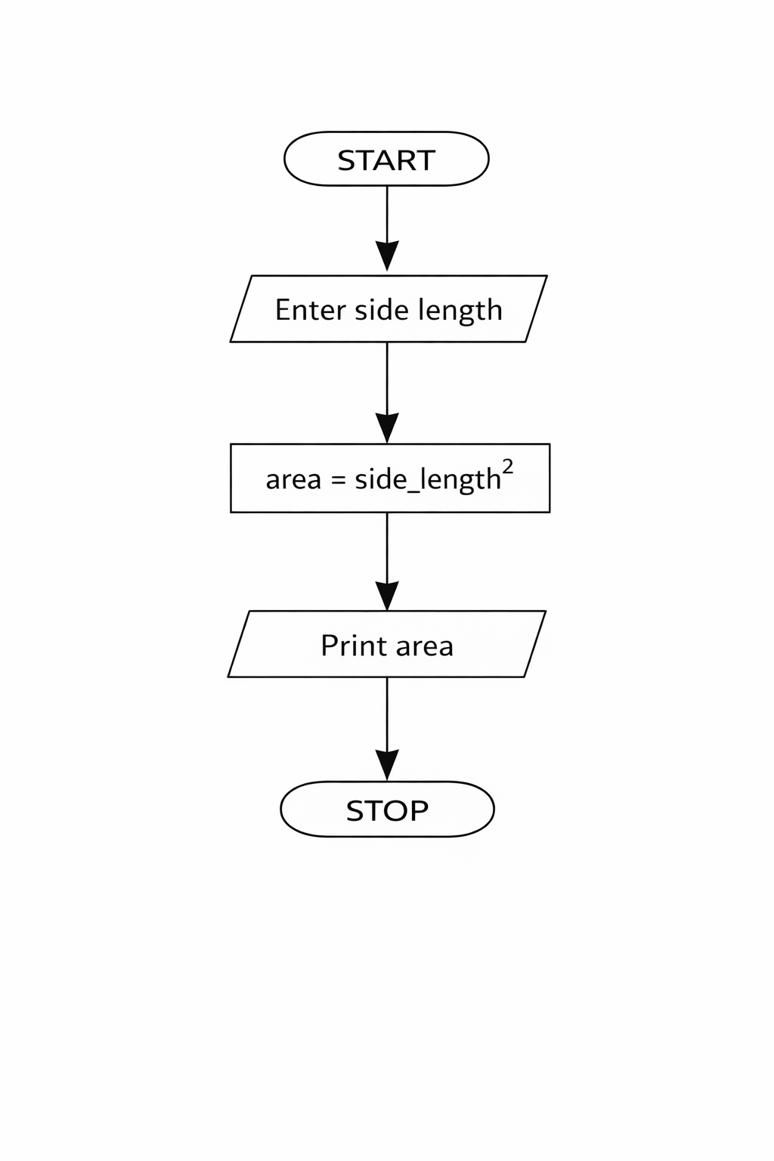
Python code
side_length = int(input())
area = side_length ** 2
print(area)

EXCECUTION
